Business Process: Kubra Bill (QA) Review

Contact | Contact Person
Business Process Owner | Billing Operations
Subject Matter Expert(s) | Amanda De La Cruz, Katherine Martinez
Key Contact | Maya Duarte
Key User(s)/Role | Sr. CSR, Revenue Analyst
Date Documented | 7/26/2017

Business Process Overview
Customer Operations’ Billing Services department performs daily quality assurance checks on customer bills that are displayed digitally in MyAccount. Billing Services will review randomly selected bills from all Commercial and Residential rates and check the content of the digital bill for:
- Alignment
- Fonts
- Display
- Accuracy
- Graphs
- Links

Prerequisites and/or Dependencies
  - RDI File is processed successful
  - Rate/Account type is supported by Digital Bill

Business Process Assumptions
(Assumptions pertaining to the business process)
Process | - Kubra and Open Text validations completed successfully for Digital Bill to display.
People | - SAPCCS  - IT Web  - COS
Technology | - SAP  - Open Text  - ESB  - Web Database  - Service Now

Process Flowchart
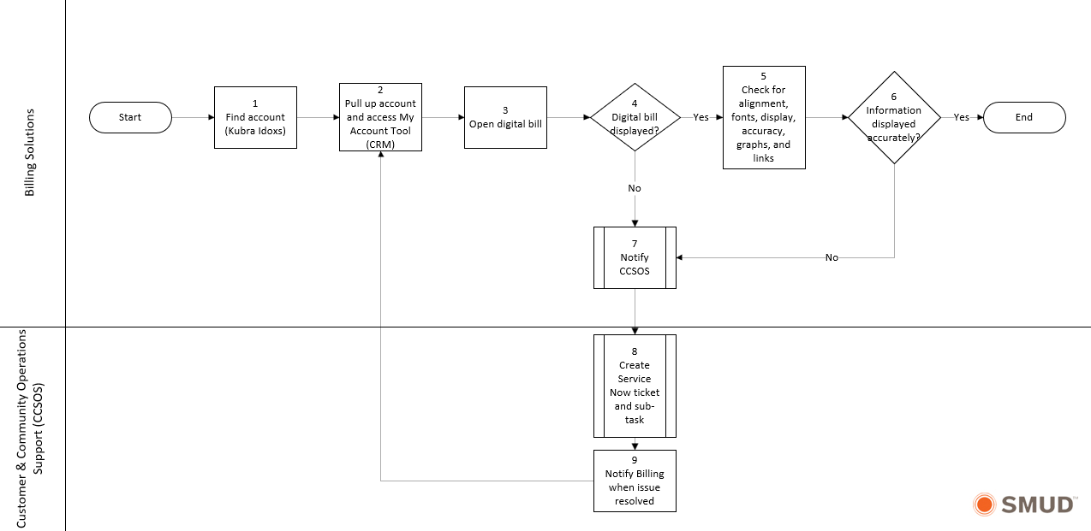

Task Description
Id | Task Description | Procedure
1 | Find account in Kubra iDoxs | Find accounts in scope for Digital Bill utilizing Kubra iDoxs
2 | Pull up account and access MyAccount Tool | Using link in CRM tool section enter contract account number and issue date of bill
3 | Open digital bill | Click on the “view bill” link in MyAccount
5 | Check for alignment, fonts, display, accuracy, graphs, and links | Perform a side-by-side comparison of the digital bill and the PDF print version on the bill
7 | Notify COS | Notify COS via email with description of issue
8 | Create Service Now ticket and sub-task | COS creates a Service Now ticket for their tracking, then creates a sub-task and assigns it to IT-Customer (SAPCCS)
9 | Notify billing when issue resolved | COS notifies Billing once the issue is resolved

Business Rules
Id | Event Name | Business Rules
3 | Open digital bill | - The digital bill should be available for QA after 9am weekdays and review should be complete by 9:45am  - Billing Solutions should begin a QA check of bills once available
7 | Notify COS | - Billing Solutions will notify COS of any issues with the digital bill (incorrect amounts, formatting issues, or no display, etc.,)  - Billing Solutions will email Sr’s and Supervisor to advise of any issues  - Billing Solutions Rep will add issues to a QA KUBRA Issue tracking spreadsheet

Event | Legal Requirements (Optional)  Legal documents/ procedures/ requirements to be fulfilled before/at the specified event.
Id | Event | Legal Requirements

PART B – Formal System Changes

Technical Requirements
Id | Event Name | Requirement

Itron/SAP/SSN/Other (Optional)
Undertaking Doc. No. | Date submitted | Date approved | Undertaking description
Doc ID as assigned by project(BTSR, Altiris ticket #, etc. |  |  | Description of task to be undertaken.

PART C – Change Management & Training

Departments impacted by process change (Required)

Department | Type of Change(s) | Action Required
Revenue Operations Support | Training documentation,  QA Processes | Lead QA effort, develop and deliver training, develop and distribute documentation
Billing Operations | Timing of QA process, format of Digital Bill and access to portal | Assist QA Process, training, documentation validation

End User Training Impacts (Required)

End User Audience | Training Required | Training Delivery Method | Timing/Dependencies
Billing Operations | End User Training | Various training delivery

PART D – Process Controls and Document Tracking

Process Tracking
(For each Event, identify relevant measurements, occurrences, frequencies, etc.)
Id | Event Name | Metrics

Supporting Documentation
(Any subsequent documentation in support of this business process (i.e. business requirements, technical specs, etc.) shall be summarized in the following table.)
Document Type | Author | Link
Digital and MAOC Transition to Operations Plan | Christie Rodriquez | Digital Bill - Transition to Operations Plan
Digital Bill and MAOC Operational Support Plan | Christie Rodriquez | Digital Bill - Operational Support Plan

Stakeholders
(Required signatures for all stakeholders of this process)
Name | Job Title | Department | Date
Maya Duarte | Supervisor, Billing Solutions | Billing Operations
Jessica Shaw | Manager, Customer Operations Support | Customer Operations Support

Business Blueprint Amendments

Any subsequent changes to this business process blueprint after the official document approval shall be summarized in the following table. This document must be reprinted and signed by the authorized representatives.
Version | Author | Description of Change | Approval (Name/Sign) | Date
v.0 | Miyoshi Carlisle | Document creation |  | 7/26/2017
v.1 | Sabrina Hudson | Updates to contact information, process steps, and business rules. |  | 7/24/2025

